New CEEPUS Network Desktop
First steps

Get used to the new design of the CEEPUS network application software
Please allow some time to get used to the new design of our software. The basic features stayed the same.
On the left side you will now find the navigation bar to access all features for your “network” role. On the main desktop you will find the most important tasks for you as quick links.
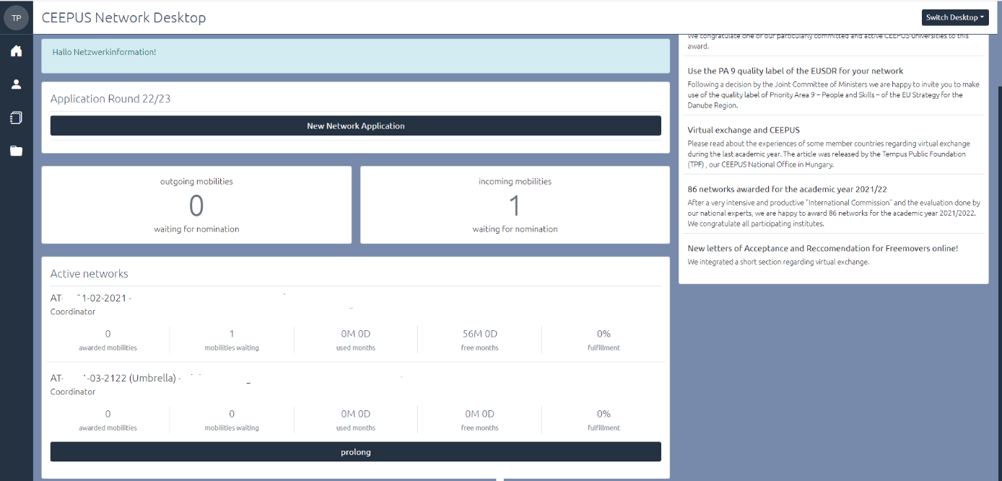

- Quick links:
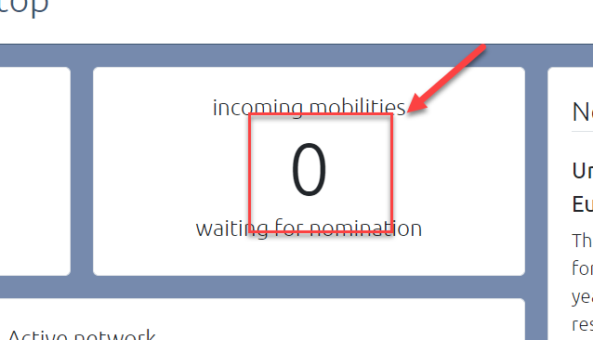
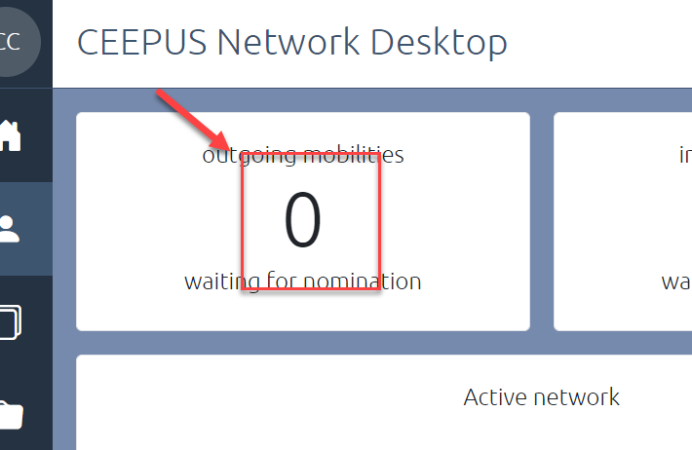
Mobilities: View and access the outgoing mobilities for your participating unit and the incoming mobilities waiting for nomination directly!

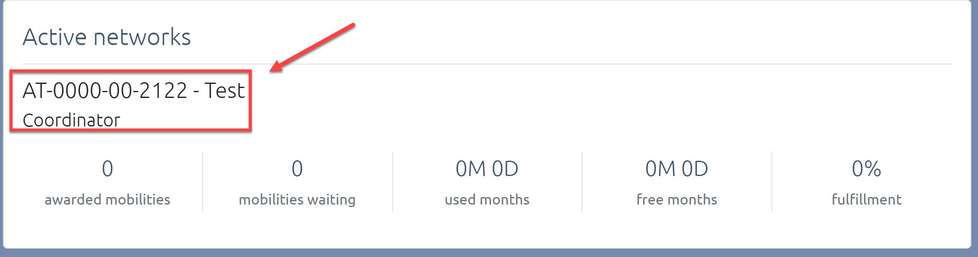
Access your active and running network in the academic year 2021/22 or in 2020/21

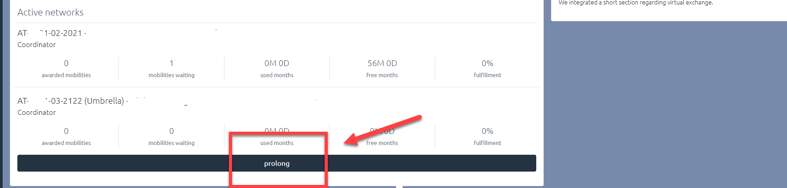
Prolong your network from 2021/22 to 2022/23.

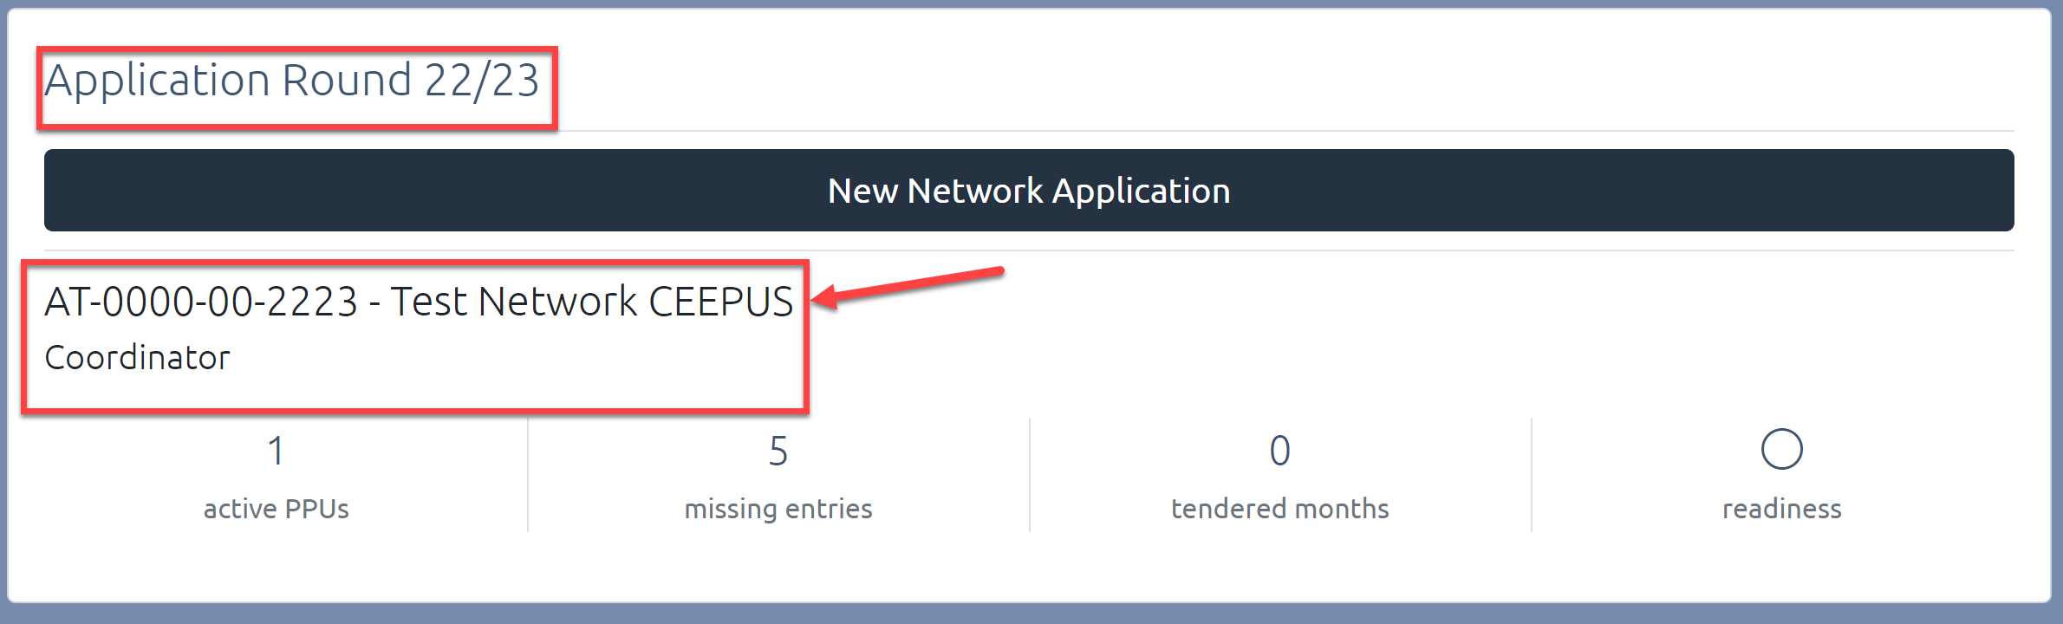
Access your new network application for 2022/23 after the prolongation.

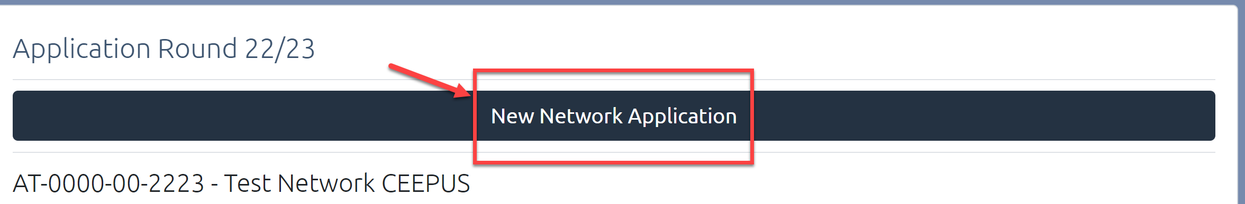
Caution: If you press New Network Application, you will start a brand-new application.

- Navigation Bar:
You will find the navigation bar on the left side of your desktop
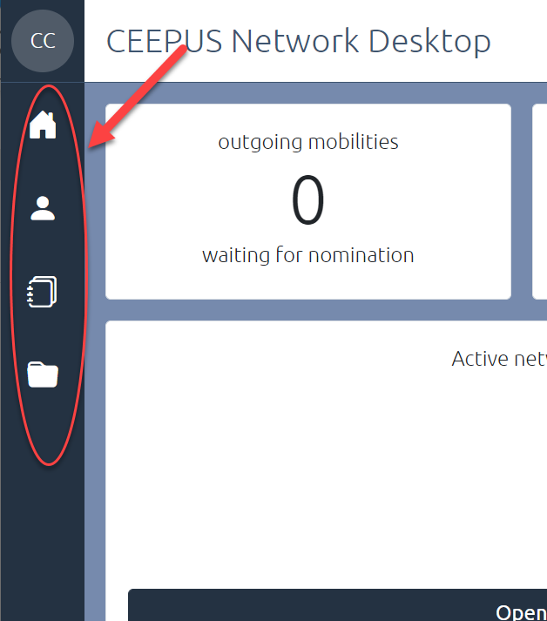

Home button: return to your Desktop.

Person button: view and change your personal settings

Application Data button: Manage your mobility and network applications

Basedata button: Edit your participating unit data

- Live support:
During your online application you will have access to our help section and the technical live support by clicking the question mark.
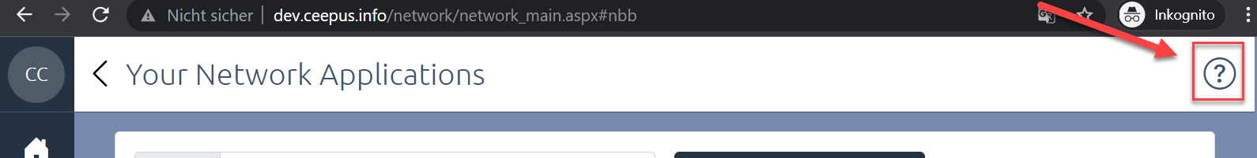

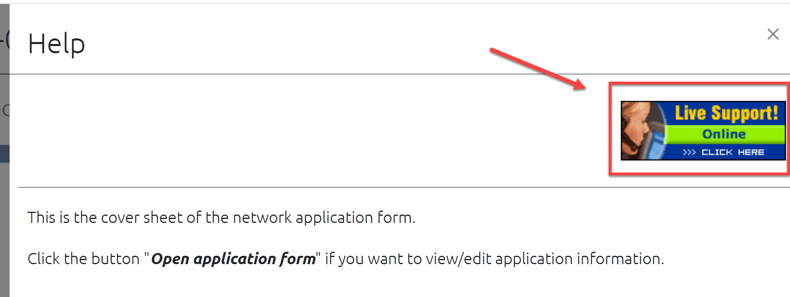

If you pin the Help, it will remain on the right hand side of your desktop during the process of your application.
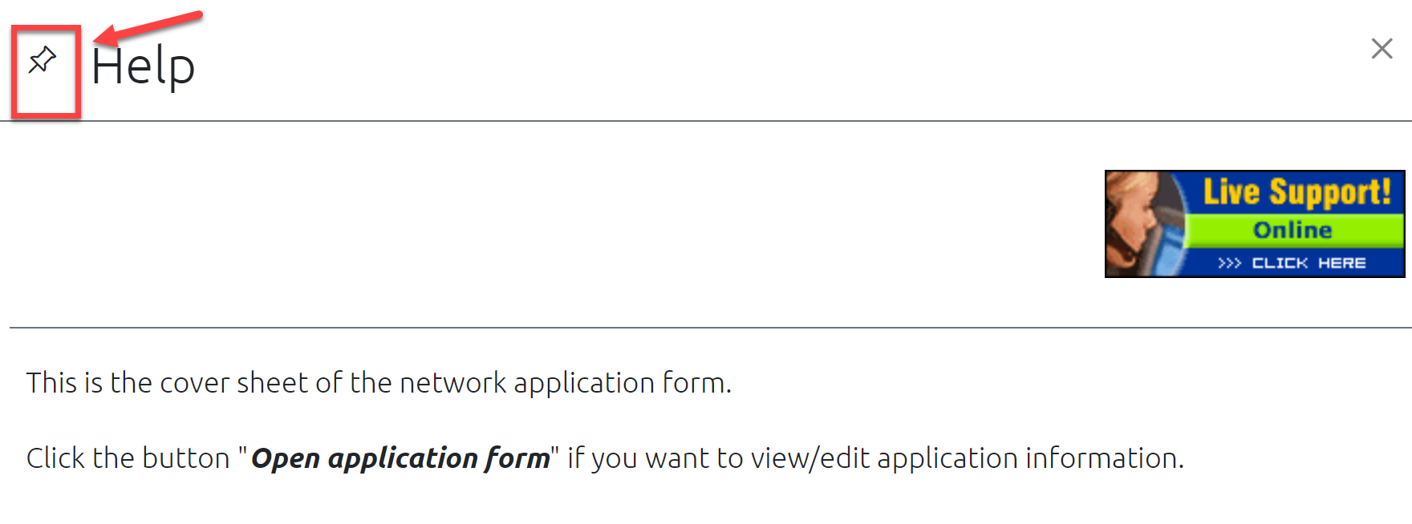

- First steps for network application round 2022/23

- Access your unfinished network application for 22/23 after prolongation at any time directly on your Network Desktop:

- You will access the main page of your application:

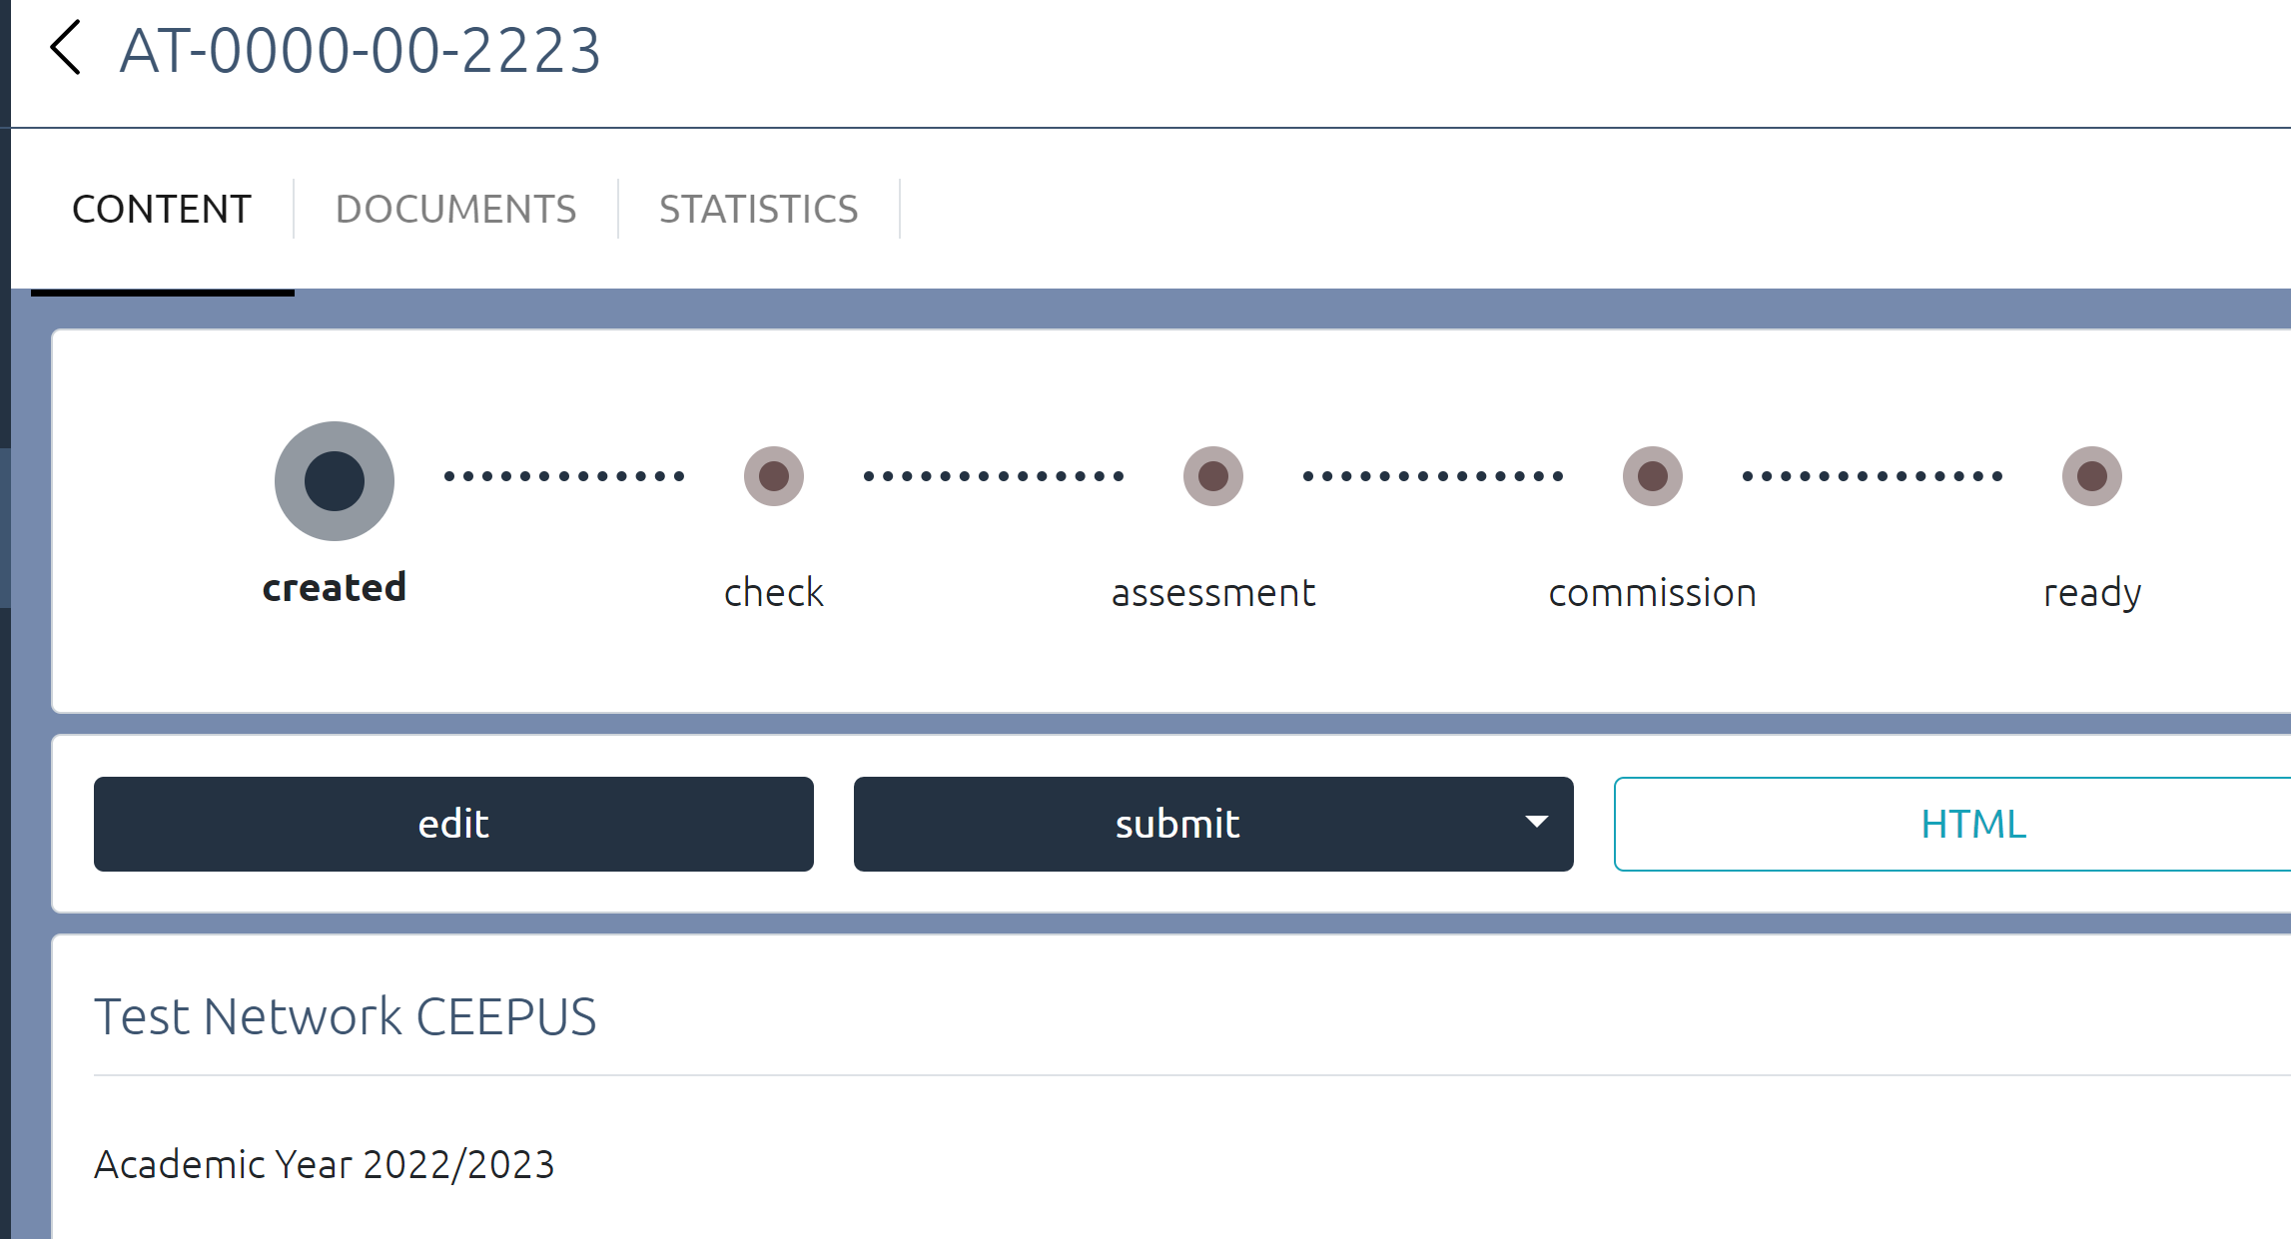

- Use the “HTML” button for print out:

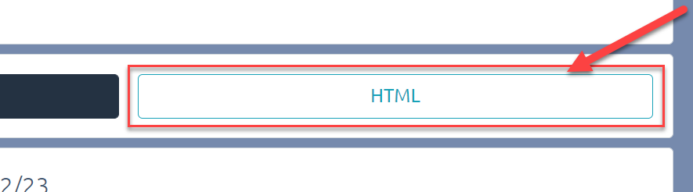

- Press “Documents" for an overview of your documents etc.

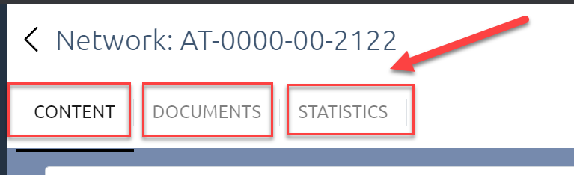

- Press the “Edit” button to excess your network application:

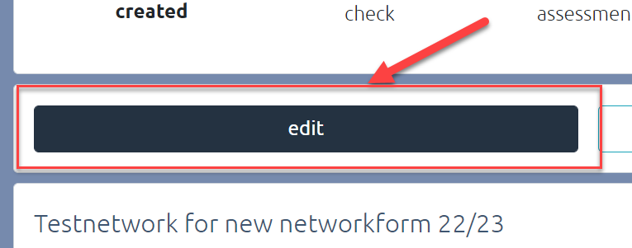

- You will now see the overview of your application:

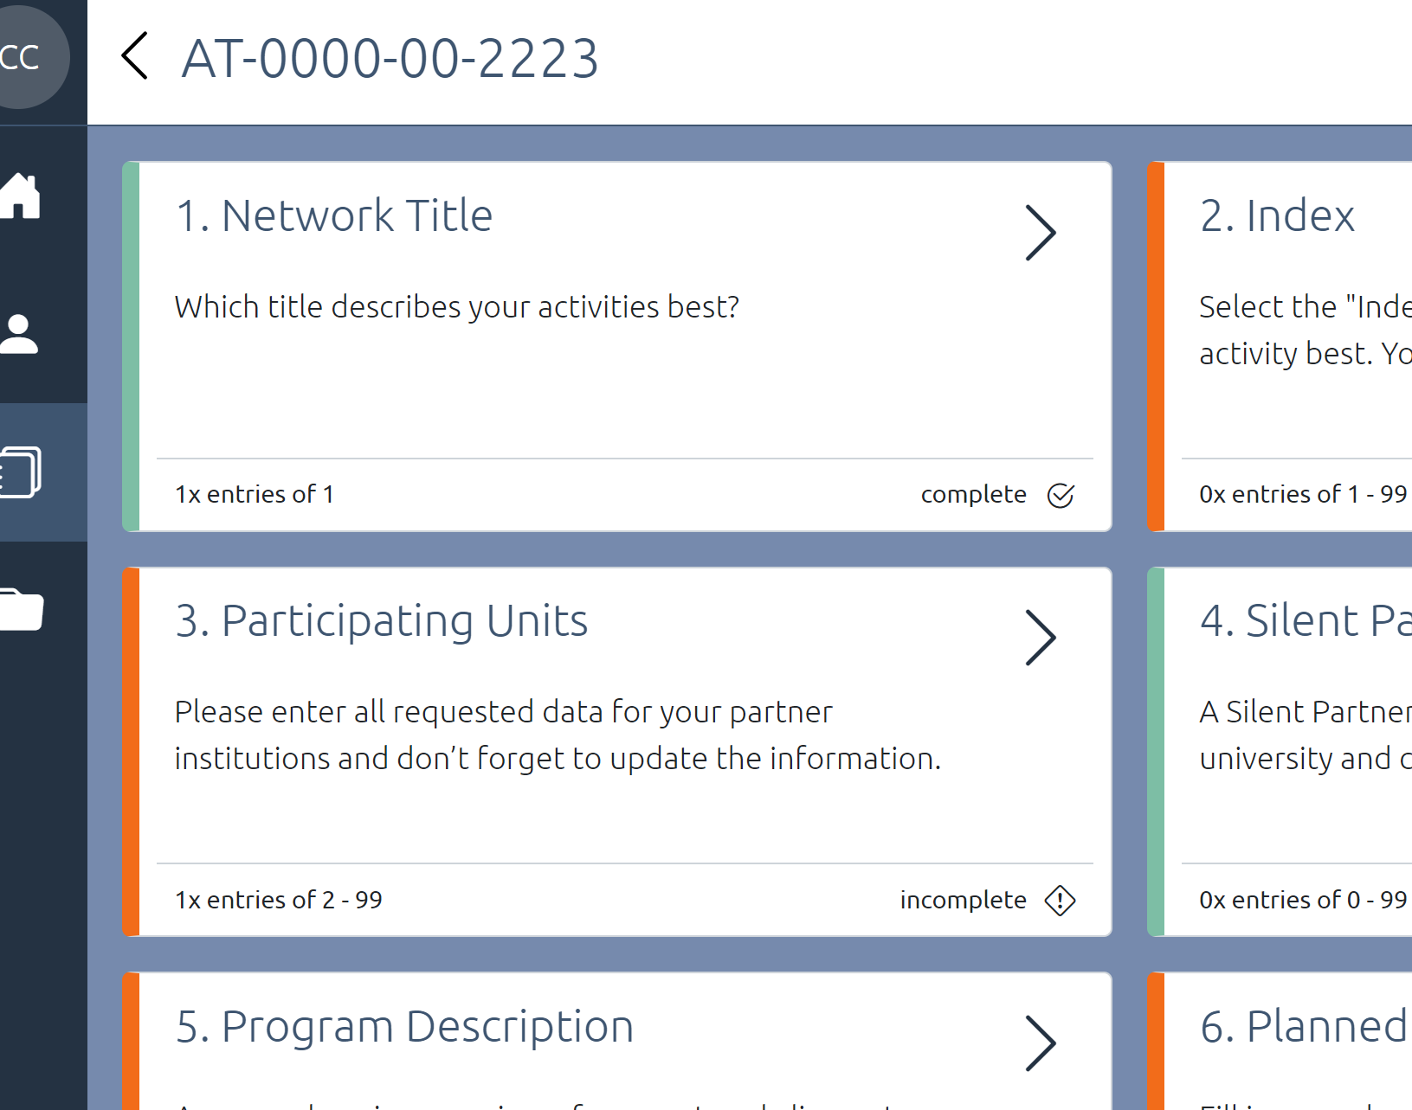

- Press on the respective section to open and edit the different sections of the application

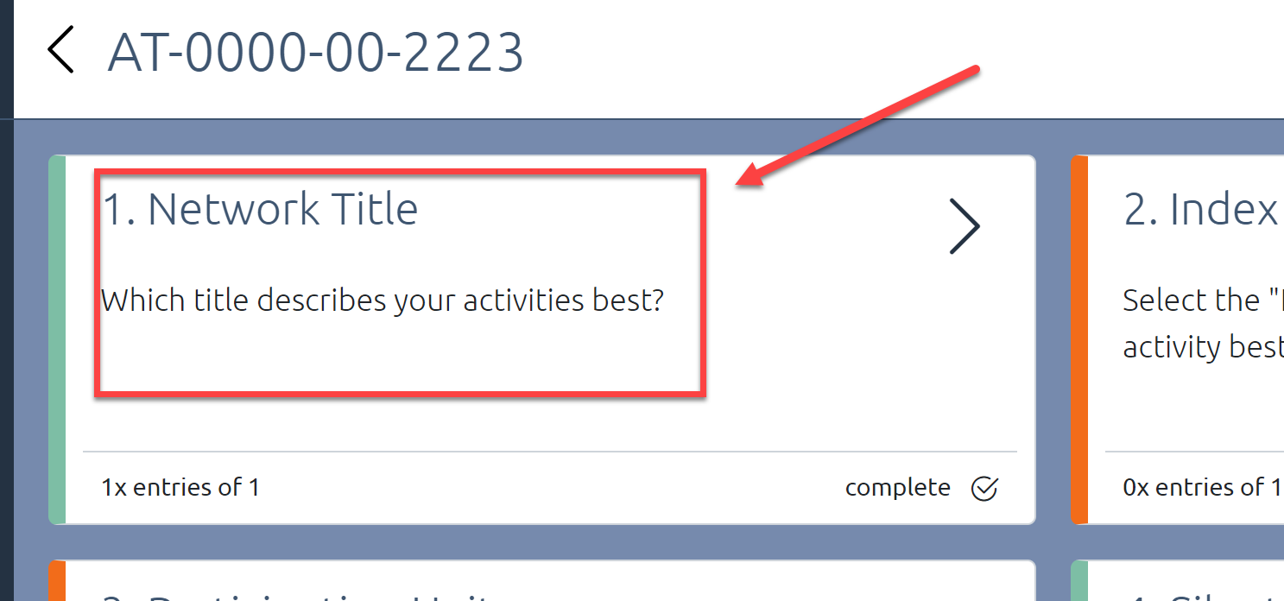

- Please be aware, that not all sections are copied this year during prolongation

- A green bar indicates a completed section
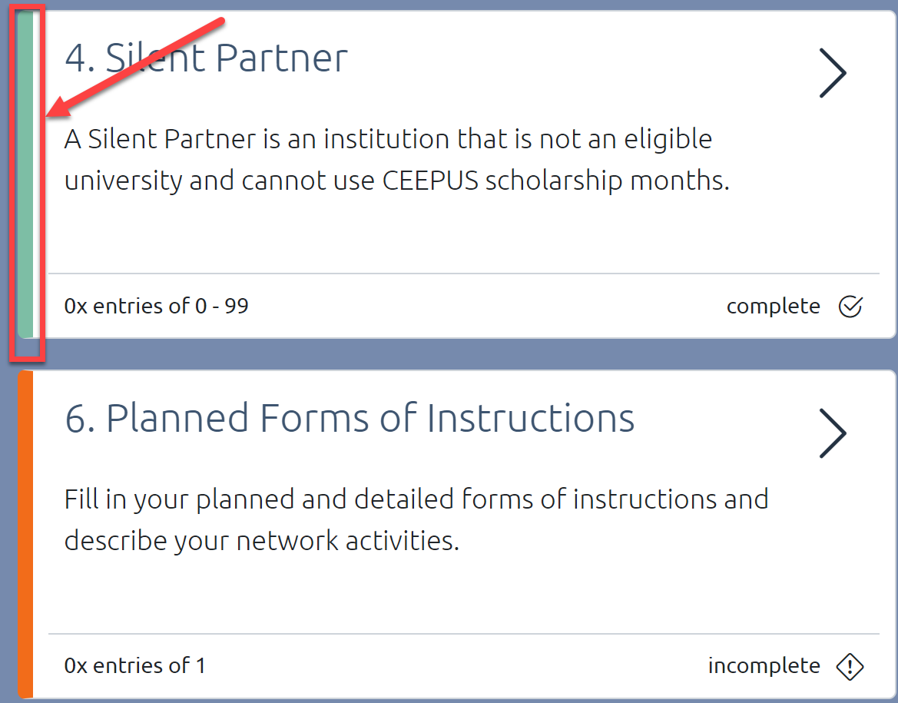

- Navigate back to your network overview

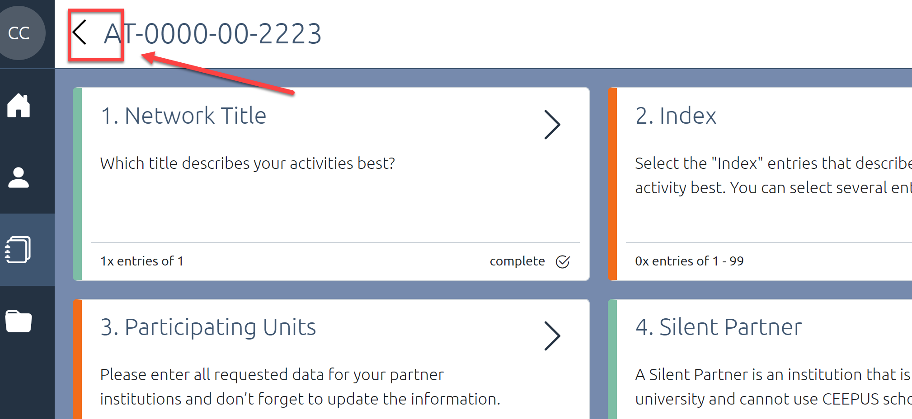

- Don’t forget to submit your application (after you are finished):

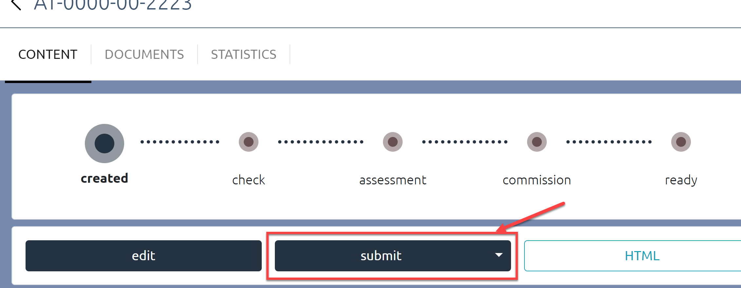
.
- For technical help get in contact with support@ceepus.info

